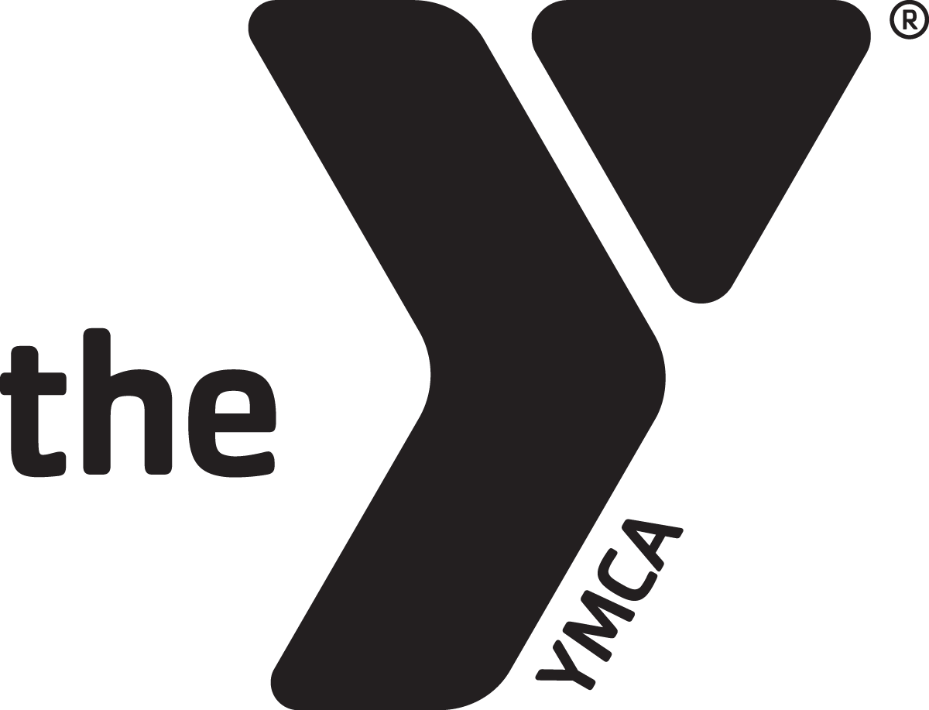

Notice: There may be a 48 hour (two full business days) waiting period between when a registration form is turned in at the Welcome Center and when a student can attend summer camp.

Please initial that you are in receipt of the following:

__________: YMCA Summer Camp Handbook

__________: Paid the $30.00 Registration Fee

__________: Turned in COMPLETED YMCA Summer Camp Registration Form

Please check one of the following:

__________: Full Time (3-5 days per week)

__________: Drop In (1-2 days per week)

__________: Preferred Start Date

Date:______________________________________

The Hot Springs Family YMCA
130 Werner Street
Hot Springs, AR 71913
www. hsymca.com

