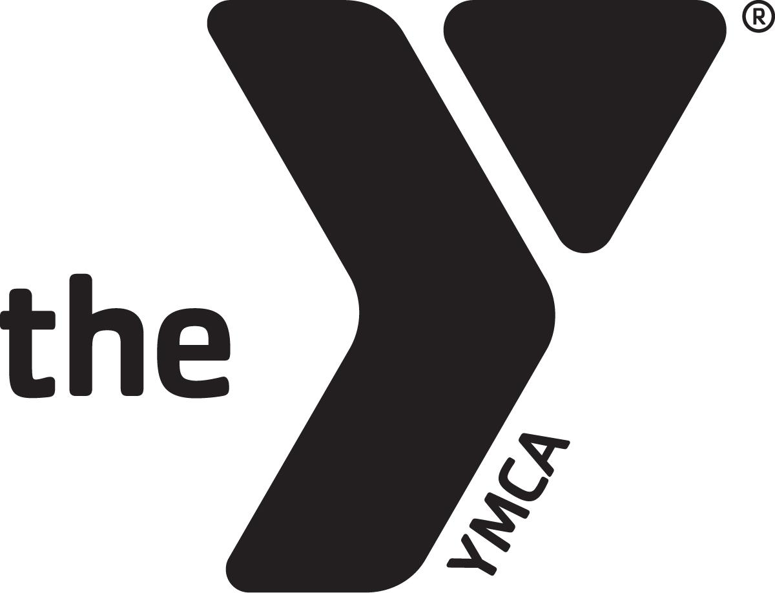 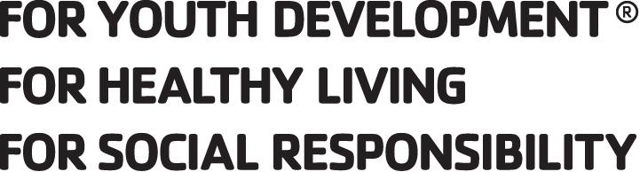 SUMMER CAMP 2020 SCHEDULE
PRE-K WEEK 2, JUNE 8-12, 2020 LET’S GET MESSY
Monday | Tuesday | Wednesday | Thursday | Friday
7-8AM: ARRIVAL | 7-8AM: ARRIVAL | 7-8AM: ARRIVAL | 7-8AM: ARRIVAL | 7-8AM: ARRIVAL
8:OO-8:15: BREAKFAST | 8:OO-8:15:BREAKFAST | 8:OO-8:15: BREAKFAST | 8:OO-8:15: BREAKFAST | 8:OO-8:15: BREAKFAST
8:15-8:45: CIRCLE TIME | 8:15-8:45: CIRCLE TIME | 8:15-8:45: CIRCLE TIME | 8:15-8:45: CIRCLE TIME | 8:15-8:45: CIRCLE TIME
8:45 BATHROOM BREAK | 8:45 BATHROOM BREAK | 8:45 BATHROOM BREAK | 8:45 BATHROOM BREAK | 8:45 BATHROOM BREAK
9:00 PLAYGROUND | 9:00 PLAYGROUND | 9:00 PLAYGROUND | 9:00 PLAYGROUND | 9:00 PLAYGROUND
9:30-10:00 PHONICS  SIGHT WORDS A’s | 9:30-10:00 PHONICS  LETTER SOUNDS RACE | 9:30-10:00 PHONICS  PENCIL CONTROL WS | 9:30-10:00 PHONICS  SIGHT WORDS (A) WS | 9:30-10:00 PHONICS
10:00-10:30: 7 Habits of Happy Kids- Habit 2 | 10:00-10:30 Practice writing (all about me) | 10:00-10:30 counting to 20 skills | 10:00-10:30 Get to know my favorite thing to do. | 10:00-10:30 (DRAMA) CHARADES
10:30-11:00 Music and movement | 10:30-11:00 Music and movement | 10:30-11:00 Music and movement | 10:30-11:00 Music and movement | 10:30-11:00 Music and movement
11:00-11:30 LUNCH | 11:00-11:30 LUNCH | 11:00-11:30 LUNCH | 11:00-11:30 LUNCH | 11:00-11:30 LUNCH
11:30 READY FOR REST TIME/ STORY TIME | 11:30 READY FOR REST TIME/ STORY TIME | 11:30 CHANGE FOR Y  11:45 LOAD BUS | 11:30 READY FOR REST TIME/ STORY TIME | 11:30 READY FOR REST TIME/ STORY TIME
12:00 REST TIME/BATHROOM BREAKS | 12:00 REST TIME/BATHROOM BREAKS | 12:00 SWIM AT YMCA  12:45-1 RETURN TO CAMP | 12:00 REST TIME/BATHROOM BREAKS | 12:00 REST TIME/BATHROOM BREAKS
1:00 FREE TIME GYM | 1:00 FREE TIME - GYM | 1:00 REST TIME | 1:00 FREE TIME - GYM | 1:00 FREE TIME - GYM
2:00 FLUFFY SLIME | 2:00 PAINTBRUSH PAINT | 2:00 SPLAT PAINTING | 2:00 SPONGE PAINTING | 2:00 BLOW PAINTING
2:30 SNACK | 2:30 SNACK | 2:30 SNACK | 2:30 SNACK | 2:30 SNACK
3:00 PLAYGROUND | 3:00 PLAYGROUND | 3:00 PLAYGROUND | 3:00 PLAYGROUND | 3:00 PLAYGROUND
4:00 CLOSING CEREMONY | 4:00 CLOSING CEREMONY | 4:00 CLOSING CEREMONY | 4:00 CLOSING CEREMONY | 4:00 CLOSING CEREMONY
4:30-6:00 CLASS ACTIVITY | 4:30-6:00 CLASS ACTIVITY | 4:30-6:00 CLASS ACTIVITY | 4:30-6:00 CLASS ACTIVITY | 4:30-6:00 CLASS ACTIVITY

