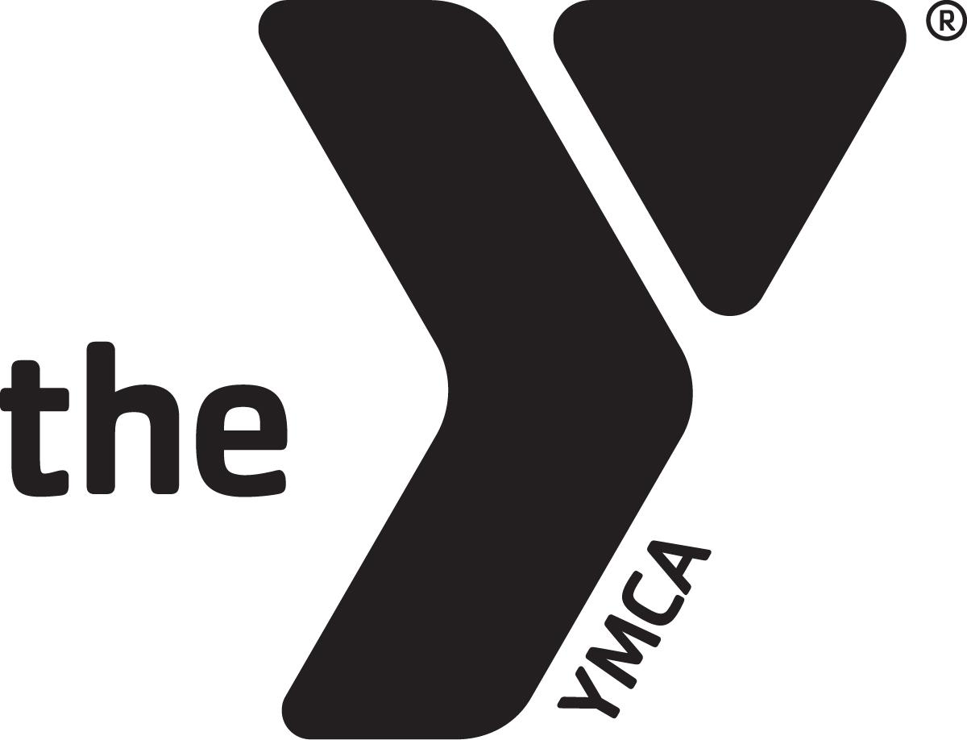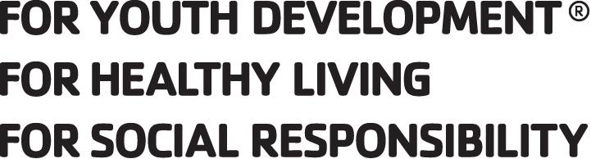 SUMMER CAMP 2020 SCHEDULE
9 & 10 YEAR OLDS WEEK 2, JUNE 8-12, 2020 LET’S GET MESSY
Monday | Tuesday | Wednesday | Thursday | Friday
7-8am:  Arrival-activity in room | 7-8am:  Arrival-activity in room | 7-8am:  Arrival-activity in room | 7-8am:  Arrival-activity in room | 7-8am:  Arrival-activity in room
8:00-8:40: Morning Meeting/Journals | 8:00-8:35: Morning Meeting/Journals | 8:00-8:35: Morning Meeting/Journals | 8:00-8:35: Morning Meeting/Journals | 8:00-8:35: Morning Meeting/Journals
8:40-9:00: Breakfast | 8:40-9:00: Breakfast | 8:40-9:00: Breakfast | 8:40-9:00: Breakfast | 8:40-9:00: Breakfast
9:00 FLUFFY SLIME | 9:00-10:00 NEXT LEVEL SPORTS | 9:00 SPLAT PAINT | 9:00-10:00 NEXT LEVEL SPORTS | 9:00 BLOW PAINT
10:00-11:00  Upper Playground -Kickball | 10:00-11:00 DIY PAINT ART | 10:00-11:00  Upper Playground - Basketball | 10:00-11:00 SPONGE PAINT | 10:00-11:00  Upper Playground  Free Time
11:00  HULA HOOP CHALLENGE | 11:00 Jump the Creek- G | 11:00 Jumping Jack Challenge- G | 11:00 Free Dance- G | 11:00Free Time Gym
12:00-12:30: Lunch | 12:00-12:30: Lunch | 12:00-12:30: Lunch | 12:00-12:30: Lunch | 12:00-12:30: Lunch
12:30-1:30: Table Games in classroom | 12:30-1:30: Table Games in classroom | 12:30-1:30: Table Games in classroom | 12:30-1:30: Table Games in classroom | 12:30-1:30: Table Games in classroom
1:30-2:30 Upper Playground | 1:30-2:30 Upper Playground | 1:30 CHANGE FOR Y  1:45 LOAD BUS | 1:30-2:30 Upper Playground | 1:30-2:30 Upper Playground
2:30-3:30 ART TIME | 2:30-3:30 ART TIME | 2:00-3:00 YMCA SWIM AND OTHER ACTIVITY | 2:30-3:30 ART TIME | 2:30-3:30 ART TIME
3:30 Snack / TICKETS | 3:30 Snack / TICKETS | 3:30 Snack / TICKETS | 3:30 Snack / TICKETS | 3:30 Snack / TICKETS
4:00-6:00 Movie Time/DISMISSAL | 4:00-6:00 Movie Time/DISMISSAL | 4:00-6:00 Movie Time/DISMISSAL | 4:00-6:00 Movie Time/DISMISSAL | 4:00-6:00 Movie Time/DISMISSAL

