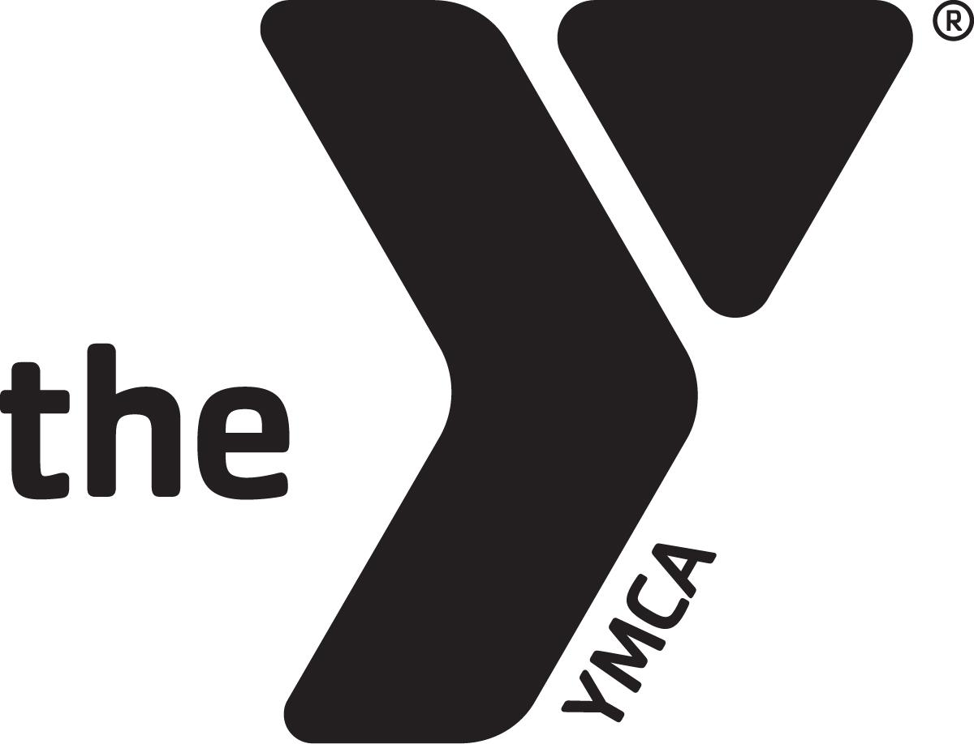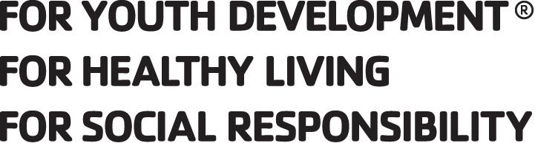 Summer Camp 2020 Schedule
11-13 year olds WEEK 2, JUNE 8-12, 2020 LET’S GET MESSY
Monday | Tuesday | Wednesday | Thursday | Friday
7-8:30: Arrival Classroom Activity | 7-8:30: Arrival Classroom Activity | 7-8:30: Arrival Classroom Activity | 7-8:30: Arrival Classroom Activity | 7-8:30: Arrival Classroom Activity
8:30 Wash  8:45 Breakfast | 8:30 Wash  8:45 Breakfast | 8:30 Wash  8:45 Breakfast | 8:30 Wash  8:45 Breakfast | 8:30 Wash  8:45 Breakfast
9:00-10:00: Upper Playground | 9:00-10:00 NEXT LEVEL SPORTS | 9:00-10:00: Upper Playground | 9:00-10:00 NEXT LEVEL SPORTS | 9:00-10:00 CLASSROOM ART
10:00-11 FLUFFY SLIME | 10:00-11 DIY PAINT BRUSH | 10:00-11 SPLAT PAINT | 10:00-11 SPONGE PAINT | 10:00 BLOW PAINT
11:00-12:00 MUSIC GUESS GAME | 11:00-12:00 UKULELE | 11:00-12:00 TABLE GAMES | 11:00-12:00 CHARADES | 11:00-12:00 UKULELE
12:00-12:30: Lunch | 12:00-12:30: Lunch | 12:00-12:30: Lunch | 12:00-12:30: Lunch | 12:00-12:30: Lunch
12:30-1:30 TABLE GAMES | 12:30-1:30 TABLE GAMES | 12:30-1:30 BOARD GAME  1:45: CHANGE FOR Y | 12:30-1:30 TABLE GAMES | 12:30-1:30 TABLE GAMES
1:30-2:30 HULA HOOP CHALLENGE | 1:30-2:30 GYM PLAY | 2:00-3:00 Y SWIM AND OTHER ACTIVITIES | 1:30-2:30 GYM PLAY | 1:30-2:30 OBSTACLE COURSE
2:30-3:3O UPPER PLAYGROUND | 2:30-3:3O UPPER PLAYGROUND | 3:00 BACK TO CAMP  3:15 WASH UP | 2:30-3:3O UPPER PLAYGROUND | 2:30-3:3O UPPER PLAYGROUND
3:30-4:00: Snack/TICKETS | 3:30-4:00: Snack/TICKETS | 3:30-4:00: Snack/TICKETS | 3:30-4:00: Snack/TICKETS | 3:30-4:00: Snack/TICKETS
4:00-6:00: MOVIE AND DISMISSAL | 4:00-6:00: MOVIE AND DISMISSAL | 4:00-6:00: MOVIE AND DISMISSAL | 4:00-6:00: MOVIE AND DISMISSAL | 4:00-6:00: MOVIE AND DISMISSAL

